ISLAMIC UNIVERSITY OF TECHNOLOGY

Organization of Islamic Cooperation

Board Bazar, Gazipur

Laboratory Report

CSE 4512

**Title**: Configuration of IPv4 and IPv6 static routing in a given network topology

**Objective**:

* Configure IPv4 and IPv6 Static and Floating Static Default Routes
* Configure IPv4 and IPv6 Static and Floating Static Routes to Internal LANs
* Configure IPv4 and IPv6 Host Routes

**Devices/Software Used**: Cisco Packet Tracer

**Theory**:

Static routing is used to manually add entries to a routing table. Although this is impractical and difficult for larger networks, it can still be done on smaller ones, which is beneficial since it does not have the same high bandwidth usage associated with dynamic routing. Even on larger networks, static routing is used as a backup system.

Static routing can be set up in two ways, using a directly connected static route or a next-hop static route. When we are routing packets to a specific destination, we can either configure the router to send the packets to an interface, regardless of how that interface is configured, or to a next-hop address, which might be configured on any interface. The former is directly connected static routing while the latter is next-hop static routing.

If we want to set up static routing for indetermined destinations, we can set the destination network prefix and prefix mask to all zeros. This creates a primary static default route.

If we have multiple static routes for the same destination address, this gives us the liberty to create a floating static route. The command to configure a static route has a parameter called a distance metric. This specifies the cost of using that route. By default, this has a value of 1. When setting up a floating static route, we give the distance metric a higher value. The router always uses the route which has the lowest distance metric, so the floating static route is only used when the main one cannot be used. This allows the floating static route to act as a backup.

**Diagram of the experiment**:

Task #01:

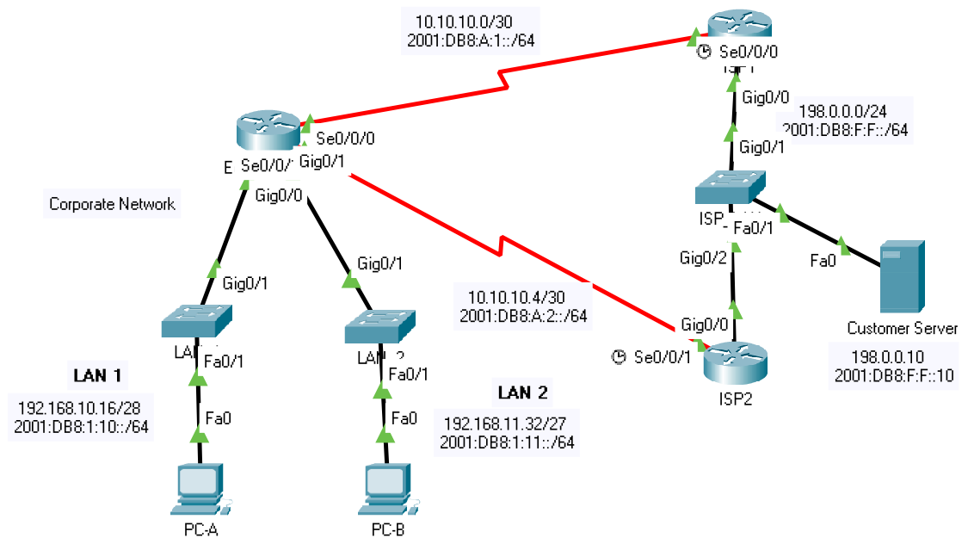

**Working Procedure**:

TASK #01:

1. Configured IPv4 static and floating static primary default routes for Edge_Router.



1. Configured IPv6 static and floating static primary default routes for Edge_Router.



1. Configured IPv4 static and floating static routes to LAN 1 and LAN2 networks for ISP 1.

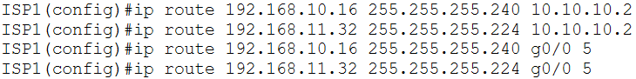

1. Configured IPv6 static and floating static routes to LAN 1 and LAN2 networks for ISP 1.

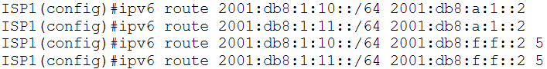

1. Configured IPv4 and IPv6 host routes to the Customer Server for Edge_Router.

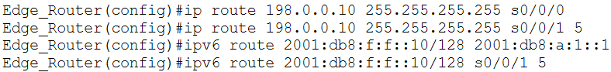

**Observation**:

From Edge_Router:

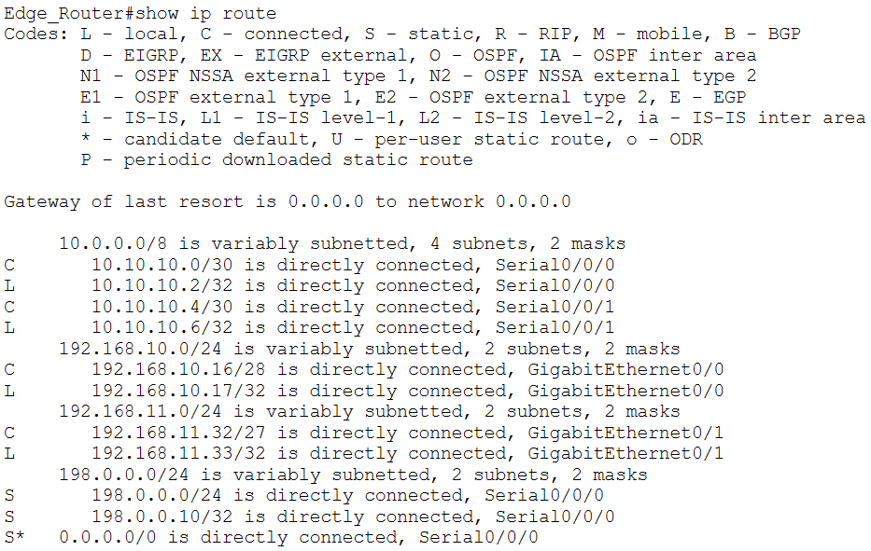

From ISP1:

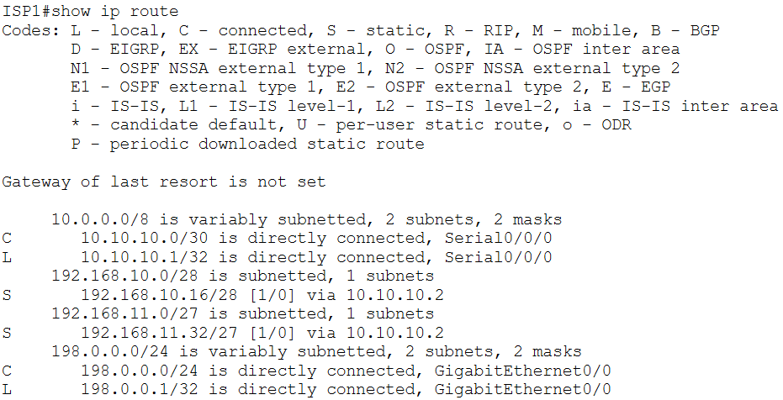

**Challenges**:

I got a little confused with the last section, where we had to configure host routes. I was under the impression that all static route commands would only ever involve network addresses, not host addresses. Clearing up this confusion took a moment.

It also appears that the activity continues to show the last task, where an IPv6 directly connected floating host route to the customer server through ISP2 must be configured on the Edge Router as incorrect even if the correct interface is provided. The issue goes away if the next-hop address is provided instead. Both versions of the command have been used, although just the required one is shown in the report.